CURRICULUM VITAE
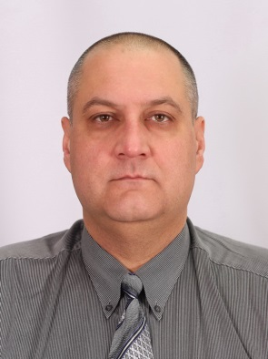
I. Personal data
Name: Ihor BOLOTYUK

Address: | Gagarina str., 13/3, Kamianets-Podilsky city, UKRAINE, 32300
Phone (Home) in Ukraine  Phone (Mobile) |  | +380 384938632  +380 977486213  +380 639903959
E-mail |  | igorpb@yandex.ua igorpb@i.ua  igorpbua@gmail.com

DOB: |  |  | january, 02, 1967
Nationality |  |  | ukrainian
Gender |  |  | male
Marital status |  |  | married
II. Education and qualifications
1983-1989 – Chernovtsy State Medical Institute, UKRAINE (USSR);
1989-1990 – Specialty “general surgery” based on the Kamianets-Podilsky city hospital, UKRAINE (USSR);
1990 – Military medical Academy of Kirov, Leningrad, (USSR), Courses of improvement of qualification on a cycle «Urgent thoracic, abdominal and military-field surgery»;
1997 – Vinnitsa medical institute of Pirogov, Vinnitsa, UKRAINE, Courses of improvement of qualification on a cycle “Surgery of urgent conditions”;
2002, 2007, 2012 – Faculty of improvement of qualification in National Medical university of Pirogov, Courses of improvement of qualification on a cycle “Planned and urgent surgery”.
III. Summary of relevant work experience
1989-2002 – Surgeon of Kamianets-Podilsky city hospital, Kamianets-Podilsky, UKRAINE;
2002-2003 – Senior medical officer of Mine Action Tasks Forces,
United Nation interim forces in Lebanon (UNIFIL), LEBANON;
2003-2009 – Surgeon of Kamianets-Podilsky city hospital, Kamianets-Podilsky-city, UKRAINE;
2009-2010 – Surgeon of Al-Refai hospital, Taiz-city, YEMEN;
2010-2012 – Surgeon of Kamianets-Podilsky city hospital, Kamianets-Podilsky-city, UKRAINE;
2012 (apr-sept) – International Company “Global Offshore Project”, Benghazi, LIBYA;
2012-2013 – Surgeon of Kamianets-Podilsky city hospital, Kamianets-Podilsky, UKRAINE;
2013-2015 – Surgeon of Tobruk Medical Centre, Tobruk-city, LIBYA.

IV. Languages
Native language |  | Ukrainian & Russian
Other languages |  | English |  | Arabic
Reading |  | + |  | -
Writing |  | + |  | -
Verbal |  | + |  | +
“I CERTIFY THAT ALL INFORMATION STATED IN THIS RESUME IS TRUE AND COMPLETE TO THE BEST OF MY KNOWLEDGE.”

15 sept 2015 Ihor BOLOTYUK, MD

