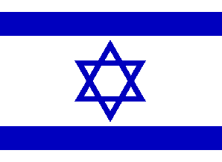
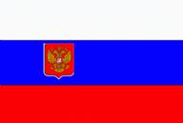
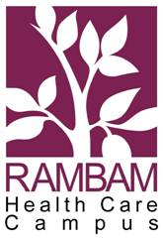

THE FIRST
ISRAELI-RUSSIAN ORTHOPAEDIC CONFERENCE

ADVANCES IN RECONSTRUCTIVE ORTHOPAEDICS AND TRAUMATOLOGY

December 27-28, 2005
Rambam Health Care Campus,
HAIFA, ISRAEL

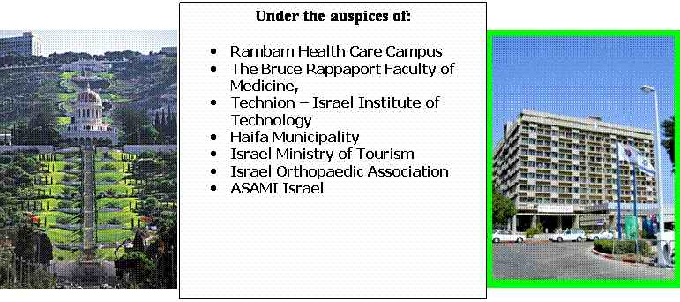
President
Michael Soudry M.D. (Israel)
Co-Chairmen
Vladimir Shevtsov M.D. (Russia)
Alexander Lerner M.D. (Israel)

Steering committee
M. Soudry M.D., Shevtsov M.D., A.Lerner M.D.,
M.Revach M.D., I.Perlman M.D., Z.Horesh M.D.

Master & Invited Lecturers

V.I. Shevtsov M.D. (Russia
G.P. Kotelnikov M.D. (Russia)
J. Itskovitz M.D. (Israel)
D. Paley M.D. (USA)

Coordinator
Mrs. I. Bergman

Public Relations
Mrs. Nurit Naeh

Secretaries
Mrs. Sigal Moshe
Mrs. Hanna Rosenfeld
Preliminary & Tentative Program

Monday, December 26, 2005

WELCOME COCKTAIL

Tuesday, December 27, 2005.
Registration & Opening remarks
Master Lecture: V.I. Shevtsov, M.D.
FIRST SESSION:
TRAUMA AND LIMB SALVAGE
Free papers
SECOND SESSION:
INNOVATIVE METHODS IN ORTHOPAEDICS AND TRAUMATOLOGY
Master Lecture: G.P. Kotelnikov, M.D.
Free papers
THIRD SESSION:
BONE INFECTION
Free papers

Wednesday, December 28, 2005.

FIRST SESSION:
CONGENITAL AND ACQURED LIMB DEFORMITIES
Guest Lecture: D.Paley, M.D.
Free papers
SECOND SESSION:
BASIC SCIENCE

Master Lecture: J.Itskovitz, M.D.
Free papers
THIRD SESSION
PEDIATRIC ORTHOPAEDICS AND TRAUMATOLOGY
Free papers
CLOSING REMARKS

GALA DINNER

POST-CONFERENCE TOURS – OPTIONAL PROGRAM:
(for foreign quests only)
Thursday 29.12.2005 – Visit to Nazareth and Tiberias
Friday 30.12.2005 - Visit to Jerusalem
Saturday 31.12.2005 – Dead Sea and Massada
Saturday 31.12.2005 - Haifa - New Year Celebration

General Information:

Official language
Official language is English. No translations will be provided.
Refreshments during Conference
Coffee breaks and lunch will be held near to Lecture Hall
Hotel reservation
You are encouraged to make your hotel reservation.
Dan Gardens: Single – 53$, double – 63$.
Dan Panorama Haifa Single -85$, Double-105$
Registration & Hotel Reservation
Mail completed registration form to:
Lerner Alexander, MD
Division Orthopaedic Surgery A
Rambam Health Care Campus, POB 9106, Haifa, Israel, 31096
Fax (24 hours a day) – 972-4-8542022
E-mail: congress@rambam.health.gov.il
Abstracts
The deadline of abstract application is September 30th, 2005. Accepted abstracts will be published in the Abstract Book.
Please submit your abstracts according to the following points:
Size: One page, Size A4 (max.300 words)
Font: Times New Roman, size 12
Margin: 2,5 cm on each side of the page
Header: Title must be written in capital letters, centered at the top of the page
Authors: Presenting author’s name must be underlined among all
abstract authors. Please add the author’s name, the name of
institute and address.
Oral Presentation
Each accepted oral presentation is limited to 10 minutes.
Master Lecture and Guest lecture – 30 minutes.
Only CD-ROM or USB portable drives will be accepted.
Slides are not accepted.
Climate and Clothing
It is winter in Israel at this time of the year. While temperatures can reach as low as 10ºC, day times can be sunny or rainy. It is therefore advisable to bring a jacket, raincoat, and umbrella. Dress will be informal throughout the conference.
Electricity The Israel uses a 220 volt 50Hz system, sockets have the European standard and plugs are three-prong grounded.

Advance Registration

THE FIRST
ISRAELI-RUSSIAN ORTHOPAEDIC CONFERENCE

ADVANCES IN RECONSTRUCTIVE ORTHOPAEDICS AND TRAUMATOLOGY

December 27-28, 2005
Rambam Health Care Campus,
HAIFA, ISRAEL

Name _________________________________________

Hospital________________________________________

Address________________________________________

City_____________Country_________Postal Code _____

Office Phone____________________________________

Fax Number_____________________________________

E-mail_________________________________________

Return form to:

Dr. Alexander Lerner
Division Orthopaedic Surgery A
Rambam Health Care Campus, POB 9106,
Haifa, Israel, 31096

e-mail: congress@rambam.health.gov.il

Fax: 972-4-8542022

ADVANCES IN RECONSTRUCTIVE ORTHOPAEDICS AND TRAUMATOLOGY
THE FIRST ISRAELI-RUSSIAN ORTHOPAEDIC CONFERENCE
Haifa, Israel, December 27-28, 2005
__________________________________________________________

ABSTRACT FORM

Title: ………………………………………………………………………

Author’s …………………………………………………………………...

Send this form to: Dr. Alexander Lerner
Division Orthopaedic Surgery A - Rambam Health Care Campus,
POB 9106 Haifa, Israel, 31096
e-mail: congress@rambam.health.gov.il

