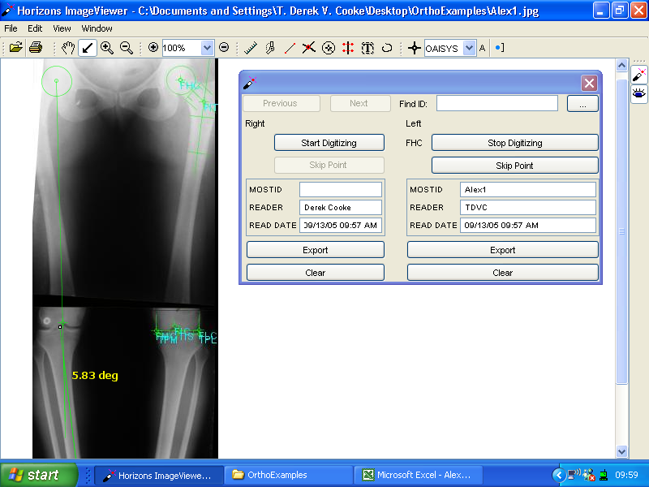
MOSTID | ACROSTIC |  | KNEE | IMAGE TYPE | READER | READ DATE | FSTM | FSTS | HKA | CH | CP | PA | FMFS
Alex1 |  |  | L | bmp | TDVC | 09/13/05 08:41 AM | -0.9 | -0.6 | -6.9 | 1.9 | 0 | -9 | 6

FSTM FemShaftTibMech
FSTS FemShaftTibShaft
FMFS FemMecFemShaft
HKA Hip Knee Ankle
Ideal HKA 0 = CH Condylar Hip (4) + CP Condylar Plateau (-1) + Plateau Ankle (-3)
Patient –7 = 2 + 0 + -9

Cooke, T.D.V., Sorbie C, Scudamore RA, Bryant JT, Siu D, Fisher B: A quantitative approach to radiography of the lower limb. J. Bone Joint Surg. 73B:715-720, 1991
Siu D, Cooke, T.D.V., Brookehoven LD, Lam M, Fisher B, Saunders G, Challis TW (1991). A standardized technique for lower limb radiography. Practice, applications, and error analysis. Invest. Radiol. 26:71-77.

